A Project Report on

Uncovering the Gaming Industry's Hidden Gems: A Comprehensive Analysis of Video Game Sales

**by**

**P. Pranoy Davis (20AT1A05A6)**

**Y. Sai Bhavesh Reddy (20AT1A05C1)**

**M. Anis (20AT1A0510)**

**P. Teja Abhinav (20AT1A05H4)**

**Under the Guidance of**

**MRS.M. JAYA SUNITHA, MTech**

**Associate Professor**



**DEPARTMENT OF ELECTRONICS AND COMMUNICATION ENGINEERING**

**G. PULLAIAH COLLEGE OF ENGINEERING AND TECHNOLOGY**

**(Autonomous)**

(Approved by AICTE | NAAC Accreditation with ‘A’ Grade | Accredited by NBA (ECE, CSE, EEE, CE) |

Permanently Affiliated to JNTUA)

ABSTRACT

Video game sales data analysis provides valuable insights into the performance and trends of the gaming industry. By examining revenue figures and units sold, analysts canidentify the top-selling games, successful gaming platforms, and geographical preferences. The data often spans multiple years, showcasing the industry's growth and evolution. This in-depth analysis allows gaming companies to make data-driven decisions, such as identifying which games and platforms are resonating with consumers and where to focus marketing efforts. Moreover, it enables stakeholders to gauge the impact of new technologies and gaming innovations on sales, keeping the industry competitive and adaptive.

The importance of video game sales extends well beyond the gaming industry, significantly impacting the global economy and culture. Economically, video games have become a major revenue generator, contributing billions of dollars annually to the economy. The industry's expansion has led to job creation, with various roles in game development, publishing, marketing, and distribution. Additionally, video games have evolved from being a niche form of entertainment to an influential cultural phenomenon. Iconic games, characters, and gaming references have become ingrained in mainstream culture, influencing art, fashion, and popular language. The cultural significance of video games extends to social interactions, as they create a global community of gamers, fostering connections and friendships worldwide.

Beyond their economic and cultural impact, video game sales have spurred technological advancements. The demand for cutting-edge graphics, immersive experiences, and innovative gameplay mechanics has driven developers to push the boundaries of technology. As a result, the gaming industry has been a catalyst for advancements in graphics processing, virtual reality (VR), augmented reality (AR), and artificial intelligence (AI). These technological breakthroughs have also found applications beyond gaming, contributing to various industries like healthcare, education, and training simulations. Video games' educational value is increasingly recognized, as they promote critical thinking, problem-solving skills, and creativity in players, making them valuable tools for learning and development. Moreover, gaming has demonstrated therapeutic potential, aiding in mental health treatment and rehabilitation.

In conclusion, video game sales data analysis plays a pivotal role in understanding the gaming industry's dynamics and impact. The growth of video games as an economic powerhouse and a cultural force underscores its importance in the modern world. With advancements in technology and an ever-evolving landscape, the significance of video game sales is expected to continue expanding, making it imperative for stakeholders to leverage data insights to stay competitive and relevant in this dynamic and influential sector.

**Contents**

**Abstract** 2

**Contents** 3

**CHAPTER 1 INTRODUCTION**  4-5

* 1. Overview 4

1.2Purpose5

**CHAPTER 2 LITERATURE SURVEY**  6-7

2.1 Existing Problem 6

2.2 Proposed Solution 7

**CHAPTER 3 THEORITICAL ANALYSIS** 8

3.1 Block diagram

**CHAPTER 4 RESULT** 9-11

**CHAPTER 5 ADVANTAGES & DISADVANTAGES** 12-13

**CHAPTER 6 APPLICATIONS**  14

**CHAPTER7 CONCLUSION** 15

**CHAPTER8 FUTURE SCOPE** 16

**CHAPTER 1**

**INTRODUCTION**

* 1. **Overview:**

Video games, in their essence, are interactive electronic games played on various platforms, such as consoles, personal computers, smartphones, and handheld devices. They offer players the opportunity to embark on virtual journeys, challenge themselves with puzzles, engage in strategic battles, and explore imaginative worlds. With the advent of cutting-edge technologies like virtual reality and augmented reality, gaming experiences have become increasingly immersive and realistic, blurring the lines between the virtual and the real.

The popularity of video games can be attributed to their versatility, catering to players of all ages and interests. From action-packed adventures to intellectually stimulating puzzles, from sports simulations to emotionally rich storytelling, video games encompass a wide range of genres, accommodating diverse preferences. Moreover, the rise of online multiplayer gaming has fostered a sense of community, connecting players from across the globe and creating social interactions within virtual environments.

Understanding video game sales is crucial for various stakeholders within the gaming industry. Game developers rely on sales data to gauge the success of their creations, identify player preferences, and make informed decisions for future game development. Publishers and marketers use sales data to strategize marketing campaigns and distribution plans, ensuring that games reach their target audiences effectively.

In conclusion, video games have transformed from simple pastimes to a global phenomenon that influences culture, economy, and technology. The analysis of video game sales data provides valuable insights into the industry's performance, growth trends, and consumer behavior. As video games continue to captivate hearts and minds worldwide, studying their sales becomes imperative for shaping the future of this thriving and ever-evolving form of entertainment.

* 1. Purpose:

* Understanding Market Performance: Video game sales analysis provides a comprehensive view of the market performance. It helps stakeholders understand which games, genres, or platforms are most popular among consumers, allowing them to identify trends and preferences.

* Identifying Successful Titles and Franchises: By analyzing sales data, developers and publishers can identify successful video game titles and franchises that have resonated well with players. This knowledge can guide future game development and investment decisions.

* Assessing Revenue Generation: Sales analysis helps in assessing the revenue generated by different games and platforms. It provides an understanding of which games are the most profitable and contribute significantly to the overall revenue of the industry.

* Evaluating Marketing Strategies: The analysis of sales data enables marketers to evaluate the effectiveness of marketing strategies and promotional campaigns. By correlating sales performance with marketing efforts, they can refine their strategies to better reach their target audiences.

* Gauging Market Penetration: Sales data analysis can help understand the extent to which video games have penetrated various regions and demographics. This information is valuable for expanding market reach and targeting untapped potential.

*Optimizing Distribution: For game publishers and distributors, sales analysis helps optimize distribution strategies. By analyzing sales patterns in different regions, they can allocate resources effectively to maximize sales in target markets.

* Informing Investment Decisions: Investors in the gaming industry can use sales data analysis to assess the potential return on investment for different gaming projects. This aids in making informed decisions about funding new game development or supporting existing ones.

In summary, **video game sales analysis** serves as a crucial tool for decision-making, strategy formulation, and industry assessment within the gaming landscape. It empowers stakeholders to make data-driven decisions, adapt to changing market dynamics, and stay competitive in an ever-evolving industry.

**CHAPTER 2**

**LITERATURE REVIEW**

* 1. **Existing Problem:**

Data Fragmentation: Video game sales data is often scattered across various platforms, publishers, and regions, leading to data fragmentation. This makes it challenging to obtain a complete and unified dataset, potentially leading to incomplete or inaccurate analyses.

Digital Sales Tracking: With the increasing popularity of digital game distribution, tracking digital sales data becomes more challenging than physical sales. Some digital platforms may not publicly disclose sales figures, making it difficult to capture the entire market picture accurately.

Privacy and Ethics: Analyzing video game sales data raises concerns about user privacy and ethical considerations. Ensuring that data is anonymized and collected with proper consent is essential to maintain trust and adhere to ethical guidelines.

Inconsistent Reporting: Different game publishers and platforms may use varying methods to report sales data, leading to inconsistencies in data formats and accuracy. This can hinder cross-comparison and trend analysis.

Seasonal Fluctuations: Video game sales are often influenced by seasonal trends, such as holiday seasons or major gaming events. Failure to account for these fluctuations might lead to inaccurate assessments of overall market performance.

Impact of Bundles and Discounts: Sales figures can be influenced by game bundles, discounts, or promotional offers. Separating the effect of these factors from the actual game performance can be challenging.

Limited Demographic Data: Understanding the demographics of players can provide valuable insights. However, obtaining comprehensive demographic data, such as age, gender, or preferences, can be challenging, leading to limitations in targeted analysis.

Rapidly Changing Industry: The video game industry evolves quickly, with new technologies and gaming trends emerging frequently. Analyzing sales data from previous years may not always provide accurate predictions for future market behavior.

* 1. **Proposed Solution:**

Centralized Data Repository: Creating a centralized data repository that aggregates video game sales data from various sources can help address the issue of data fragmentation. This repository should follow standardized data formats and protocols to ensure consistency and ease of analysis.

Collaboration with Digital Platforms: Collaborating with digital platforms to obtain sales data can improve the accuracy of digital sales tracking. Establishing partnerships and data-sharing agreements can provide analysts with comprehensive market insights.

Ethical Data Practices: Prioritizing user privacy and adhering to ethical data practices is essential. Implementing strict data anonymization and compliance with data protection regulations will ensure the responsible use of sales data.

Standardized Reporting Guidelines: Encouraging game publishers and platforms to adhere to standardized reporting guidelines will help eliminate inconsistencies in data formats. This will facilitate more accurate cross-comparison and trend analysis.

Control Group Analysis: Conducting control group analysis can help identify the true impact of bundles, discounts, and promotions on video game sales. This will enable a more accurate assessment of a game's performance independent of external factors.

Enhanced Demographic Data Collection: Implementing improved methods for demographic data collection, such as surveys or user opt-ins, can provide more comprehensive insights into player demographics and preferences.

Market Segmentation Strategies: Utilizing market segmentation strategies based on player demographics and preferences can help target specific audience segments effectively. This will enable better customization of marketing efforts and game development.

By adopting these proposed solutions, video game analysis can overcome existing challenges and provide more accurate, comprehensive, and actionable insights. These insights will be invaluable for game developers, publishers, marketers, and investors in making informed decisions, driving innovation, and maximizing the potential of the video game industry.

**CHAPTER 3**

**PROPOSED METHOD**

* 1. **Block Diagram:**

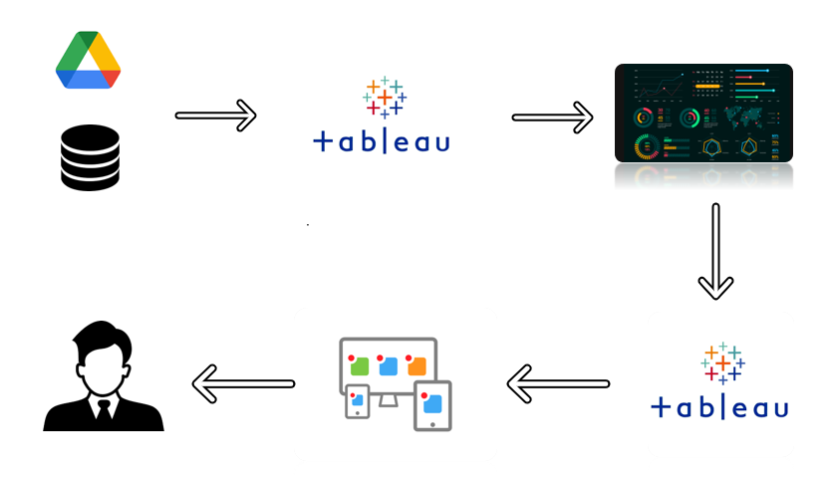

The block diagram using Tableau shows video game sales data flowing from diverse sources through data preparation and analysis, leading to interactive visualizations and actionable insights for the gaming industry stakeholders.

**CHAPTER 4**

**RESULTS**

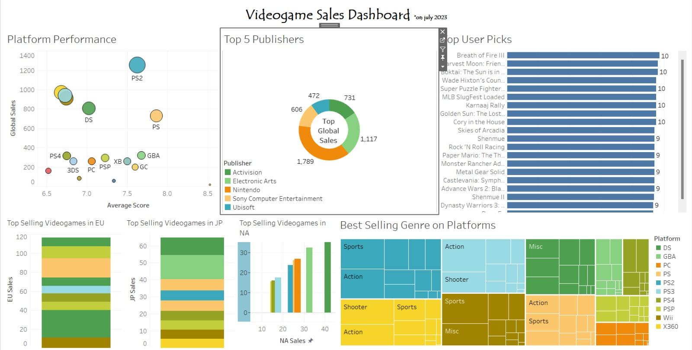

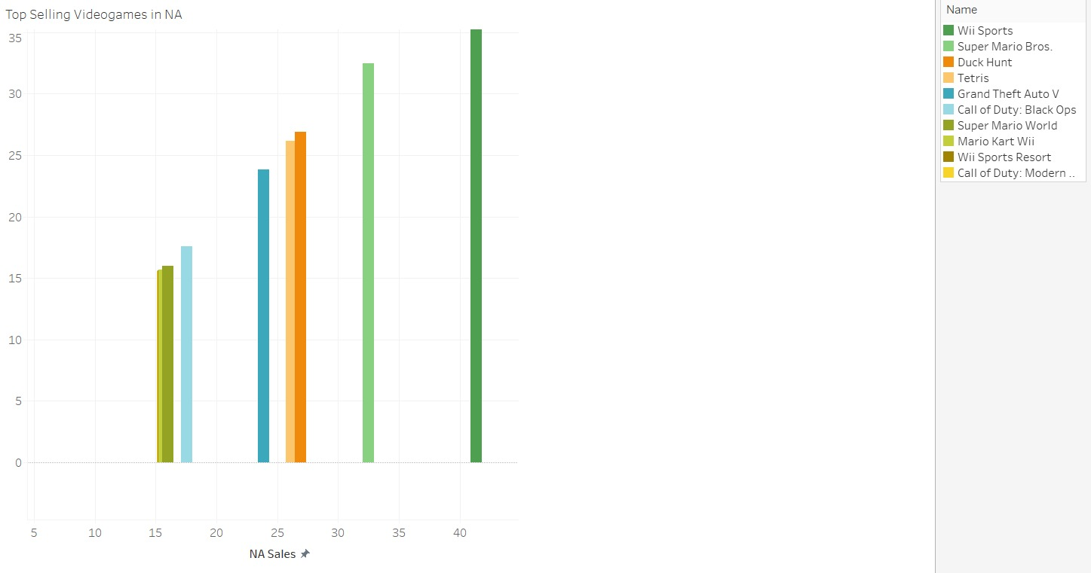

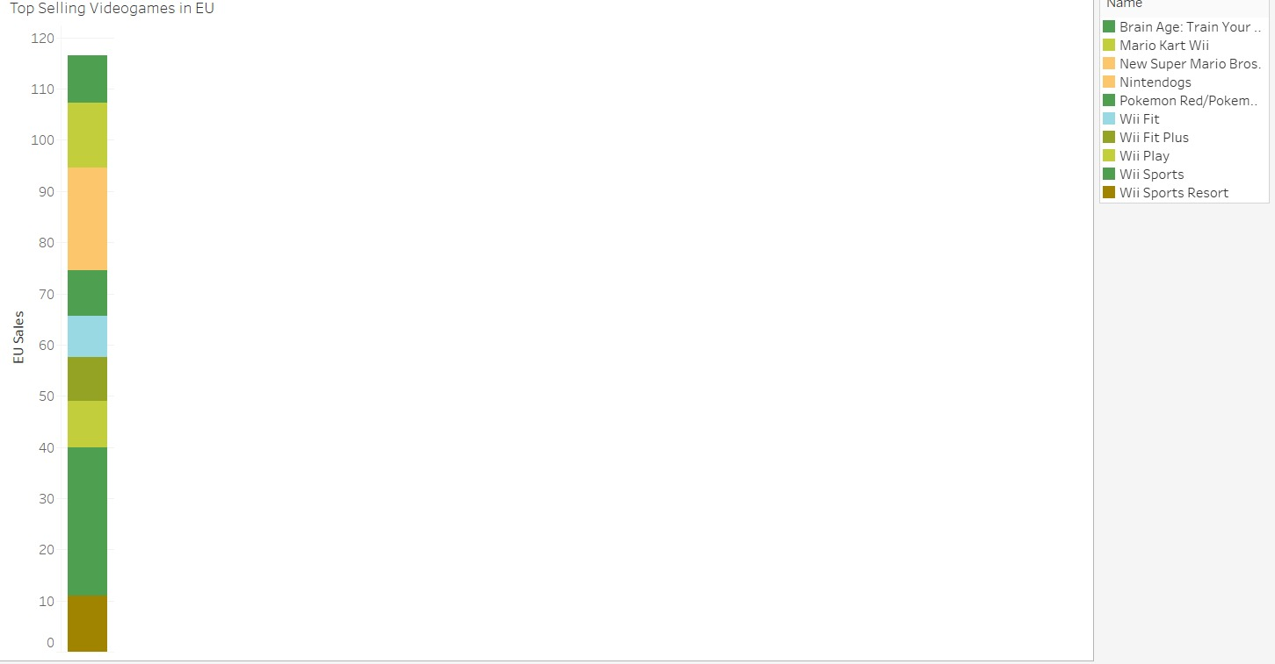

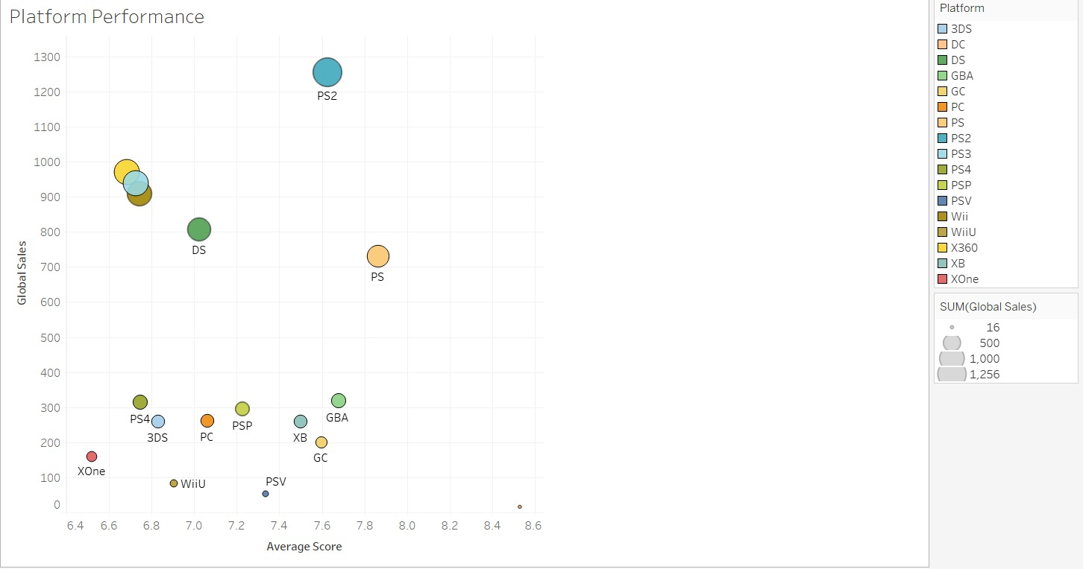0

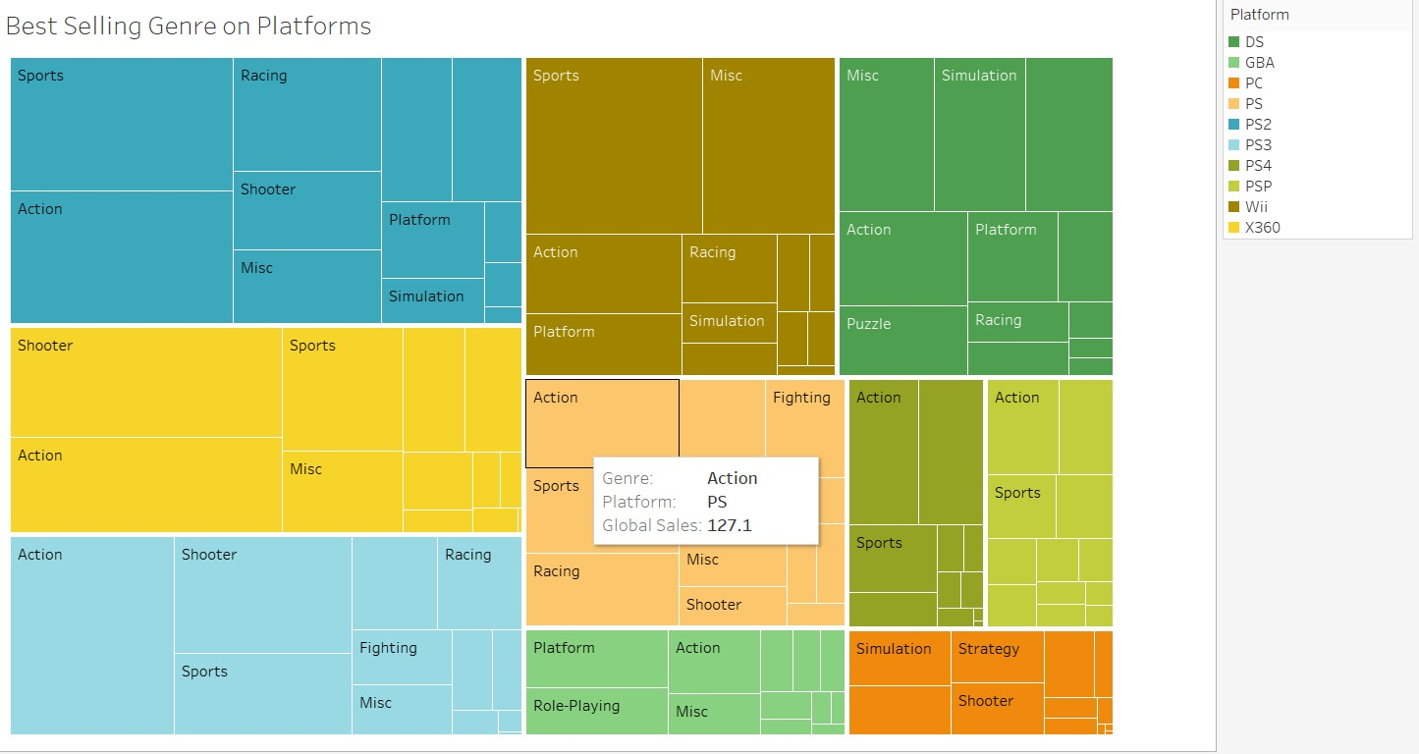

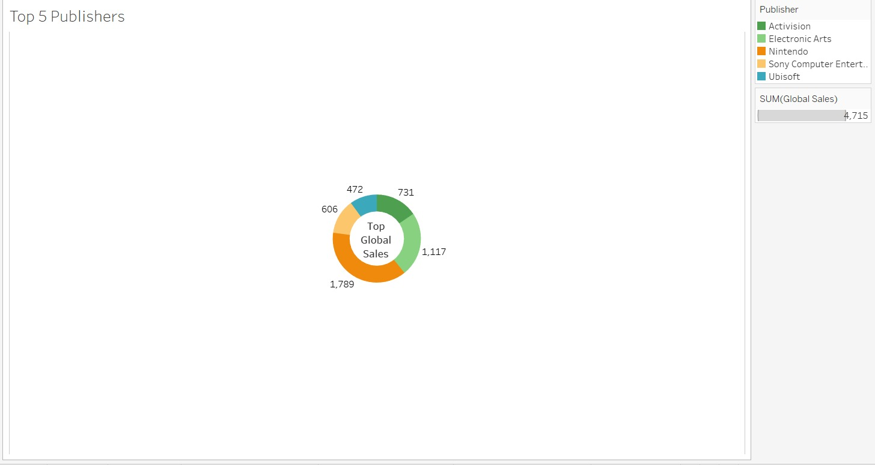

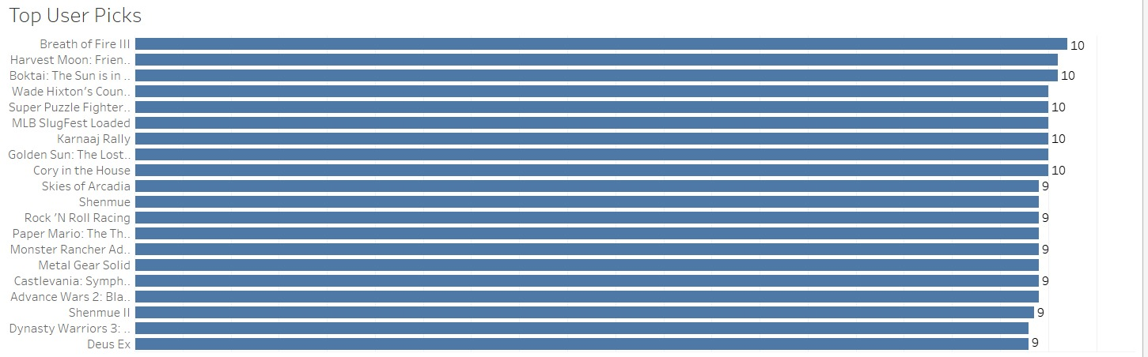

**CHAPTER 5**

**ADVANTAGES & DISADVANTAGES**

**Advantages of Video Game Analysis:**

Video game analysis brings a plethora of advantages to the gaming industry. Firstly, it facilitates data-driven decision-making, empowering developers, publishers, and marketers to base their strategies on factual insights rather than intuition. By analyzing sales data and player behavior, stakeholders can better understand player preferences and create games that align with their interests. This leads to the development of more engaging and successful games that resonate with the target audience.

Moreover, video game analysis offers invaluable market insights. Companies can identify trends, spot opportunities, and assess competition. Understanding the dynamics of the gaming market allows them to stay competitive and maximize revenue potential. By optimizing marketing strategies based on analysis results, companies can target specific audience segments effectively, leading to higher engagement and conversion rates.

Video game analysis also enables measuring game performance accurately. Developers can evaluate how well their games are received by players, identifying areas for improvement and making necessary adjustments. Additionally, the analysis reveals potential monetization opportunities, such as in-game purchases or subscriptions, enabling developers to implement effective revenue models.

Furthermore, predictive analytics can forecast future market trends and player behavior. This forward-looking approach empowers companies to plan ahead, make strategic decisions, and adapt to changing market dynamics. Overall, video game analysis serves as a powerful tool for industry players to refine their offerings, optimize marketing efforts, and drive growth in an increasingly competitive landscape.

**Disadvantages of Video Game Analysis**:

Despite its numerous advantages, video game analysis also comes with certain limitations and challenges. The vastness and complexity of video game sales data can be overwhelming, requiring sophisticated analysis tools and expertise. Handling large datasets may lead to processing challenges and potential inaccuracies, especially if the data is fragmented across multiple platforms and publishers.

Another drawback is the potential subjectivity in interpreting analysis results. While data provides valuable insights, understanding the underlying context and considering qualitative aspects is equally crucial. Relying solely on data without considering player experiences and feedback may lead to biased decision-making.

Privacy and ethical concerns arise when analyzing player data. Protecting user privacy and adhering to ethical guidelines is essential to maintain player trust and data integrity. Proper anonymization and compliance with data protection regulations are necessary to avoid any ethical dilemmas.

Moreover, obtaining comprehensive demographic data can be challenging, limiting the scope of player behavior analysis and targeted marketing efforts. The rapid evolution of the gaming industry may render historical data less relevant for predicting future trends. Failing to account for new technologies or gaming trends that emerge after the data collection period can affect the accuracy of predictions.

In conclusion, while video game analysis provides valuable insights and opportunities, it is essential to strike a balance between data-driven decision-making and creative innovation. By integrating qualitative research, player feedback, and industry expertise with quantitative analysis, companies can make well-informed decisions and create gaming experiences that captivate players and drive the industry forward. Responsible data practices and ethical considerations are crucial to ensuring the positive impact of video game analysis on the gaming ecosystem.

**CHAPTER 6**

**APPLICATIONS**

Video game analysis offers numerous valuable applications that benefit various aspects of the gaming industry and beyond. Firstly, in game development and design, analysis plays a pivotal role in shaping the player experience. By analyzing player behavior, preferences, and feedback, developers can fine-tune gameplay mechanics, level designs, and overall game mechanics to create more engaging and enjoyable games. This data-driven approach enhances the chances of developing successful titles that resonate with the target audience.

Secondly, video game analysis is indispensable in marketing and advertising strategies. By scrutinizing video game sales data and player demographics, companies can craft effective marketing campaigns. Understanding the target audience allows for the optimization of advertising channels, precise targeting, and strategic timing of campaigns. Consequently, this maximizes the reach of the game and boosts player acquisition.

Thirdly, the analysis of player spending behavior empowers developers to optimize monetization strategies. By identifying patterns in in-game purchases and microtransactions, game creators can offer attractive virtual goods, incentivizing players to invest in the game and enhancing revenue streams.

Additionally, analyzing player engagement metrics helps improve user retention strategies. By tracking playtime, session length, and player frequency, developers can identify the aspects that keep players engaged and satisfied. Consequently, developers can work to enhance player loyalty and reduce churn rates.

In conclusion, video game analysis encompasses a wide range of applications that go beyond game development and marketing. Its utility extends to driving revenue growth, enhancing player experiences, shaping strategic decisions, and even finding applications in education and health-related fields. By harnessing the power of data insights, stakeholders in the gaming industry and other domains can make informed decisions, innovate their offerings, and create impactful experiences for players and users alike.

CHAPTER 7

CONCLUSION

In conclusion, video game analysis is a vital and multifaceted tool that holds immense value for the gaming industry and its stakeholders. Through the systematic examination of sales data, player behavior, and market trends, video game analysis provides actionable insights that shape various aspects of the gaming landscape.

The advantages of video game analysis are evident in its ability to facilitate data-driven decision-making. By relying on concrete data rather than intuition, developers, publishers, and marketers can optimize game development, marketing strategies, and monetization models. This data-driven approach fosters the creation of more engaging and successful games that resonate with players, ultimately leading to increased player retention and revenue growth.

Moreover, video game analysis plays a pivotal role in understanding player preferences and market dynamics. It provides valuable market insights that allow companies to identify emerging trends, spot opportunities, and stay competitive. Armed with this knowledge, industry players can adapt their offerings to meet the evolving demands of players and capitalize on market gaps.

Despite its advantages, video game analysis also faces challenges, such as data complexity, privacy concerns, and potential biases in interpretation. To overcome these limitations, responsible data practices, ethical considerations, and a balanced approach that integrates qualitative insights are essential.

In conclusion, video game analysis is a transformative force that revolutionizes the gaming industry by guiding strategic decisions, driving innovation, and enhancing player experiences. By leveraging the power of data insights, industry stakeholders can navigate the dynamic gaming landscape with confidence, delivering captivating and immersive games that captivate players and shape the future of interactive entertainment. As the gaming industry continues to evolve, video game analysis remains an indispensable tool for success, growth, and continued excellence in game development and beyond.

CHAPTER 8

FUTURE SCOPE

The future scope for video game analysis is promising, driven by advancements in technology, data analytics, and the growing significance of the gaming industry. As data analytics technologies continue to evolve, video game analysis can benefit from more sophisticated and efficient algorithms. Machine learning and artificial intelligence can be harnessed to uncover deeper insights from complex datasets, enabling more accurate predictions and personalized experiences for players.

The rise of virtual reality (VR) and augmented reality (AR) gaming experiences opens up new dimensions for analysis. Understanding player behavior in virtual environments will be crucial for designing captivating VR/AR games and experiences. Analyzing how players interact with these immersive technologies can lead to innovative gameplay mechanics and enhanced user experiences.

Esports is gaining popularity as a competitive domain. In-depth analytics can provide valuable insights to players, coaches, and teams, helping them enhance strategies, performance, and team dynamics. Esports analytics can also offer valuable information to sponsors and advertisers looking to engage with the esports audience effectively.

The future of video game analysis will likely focus on ethical data practices, ensuring player privacy and consent. Additionally, there will be a growing emphasis on inclusive analysis to understand the diverse player base and cater to a broader audience. By integrating data analysis with behavioral psychology principles, video game developers can create games that trigger specific emotional responses and foster deeper connections with players.

In conclusion, the future of video game analysis is exciting, with tremendous opportunities for growth and innovation. By embracing cutting-edge technologies, promoting ethical data practices, and understanding player behavior more deeply, video game analysis will continue to play a vital role in shaping the future of gaming experiences, optimizing business strategies, and elevating the industry to new heights of success.